Documentation Scaffold

Data Dictionary
This section tracks all variables and data structures used throughout the API to ensure proper management and security. Only backend python/flask files are required for this section.

Data Item | Data Type | Format | Number of Bytes for Storage | Size for Display | Description | Example | Validation | File
email | String | xxxxx@xxx.xxx | 300 | 300 | A normal email | user@example.com | Have sting then a @ then more sting a dot more sting | User.py
name | String | xxxxxxxx | 300 | 300 | The user name | Bob | Be less then 300 char not all white space and also html encamping | User.py
password | String | xxxxxxxx | 512 | 512 | This is a standard password | Password@1 |  | User.py
password_hash | String | scrypt:32768:8:xxxxxxxx | 524 | 524 | The is a hash | "scrypt:32768:8:1$kQhSeSoty1qQJrr4$baa3d9a3fd1999161548619f9c0217d2ced6fed6a3d196e51afca034d617da98e6df015e11b00f7f353b1e09668b0c0b5bc55f4aa81f8f6f85dc99328d08f2ab", | Not as it is internal | User.py
session_token | String | scrypt:32768:8:xxxxxxxx | 100 | 100 |  | "scrypt:32768:8:1$kQhSeSoty1qQJrr4$baa3d9a3fd1999161548619f9c0217d2ced6fed6a3d196e51afca034d617da98e6df015e11b00f7f353b1e09668b0c0b5bc55f4aa81f8f6f85dc99328d08f2ab", | None this is internally generated | User.py
csrf_token | String | xxxxx | 100 | 100 |  | "scrypt:32768:8:1$kQhSeSoty1qQJrr4$baa3d9a3fd1999161548619f9c0217d2ced6fed6a3d196e51afca034d617da98e6df015e11b00f7f353b1e09668b0c0b5bc55f4aa81f8f6f85dc99328d08f2ab", | None this is internally generated | User.py

Vulnerability assessment
In this section, document the vulnerabilities found and how they were resolved at each development stage. Provide an analysis of all vulnerabilities identified in the API throughout development, and explain the applied solutions. Provide code samples of before and after with evidence.

Stage 1 - Basic Security:
Password Hashing:
Issue: Password stored in plain text is vulnerable if the base gets compromised, breaching the users confidentiality
Solution: Hashing passwords to make them cryptographically secure
Before | There was the password being stored in plain text in the password hash field  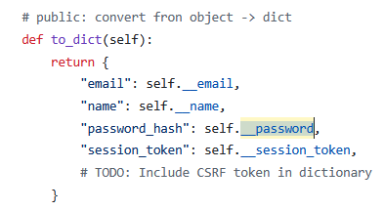  Def __init__(self)  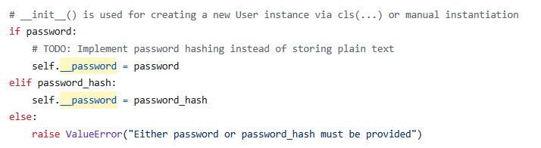
After | 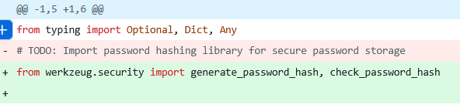  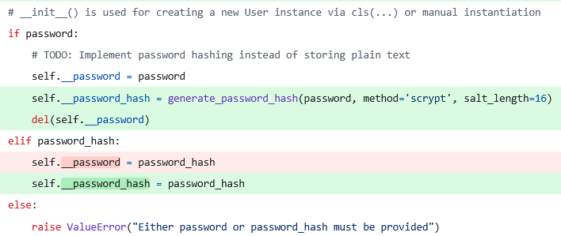  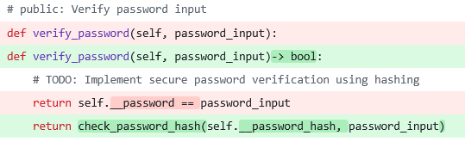  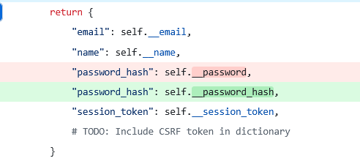  https://github.com/SoftwareDesignDevKings/at1-secure-software-freddygaffey/commit/e53ab8927eaf0c4d77fa7bdba45c7415caeeee73
Steps | I changed the logic in the __init__ so that it will not save the password in plain text ever. To fix this I used the werzeug library to hash the passwords.  I did a password hashing on the password to make it secure and I changed the variable name from password to password hash to make it clear of this change
Proof of Stage | I passed it I forgot to take a screenshot but I did pass it. You can see in the later test that is did pass it. Later I was getting this so you can infer that I have passed.  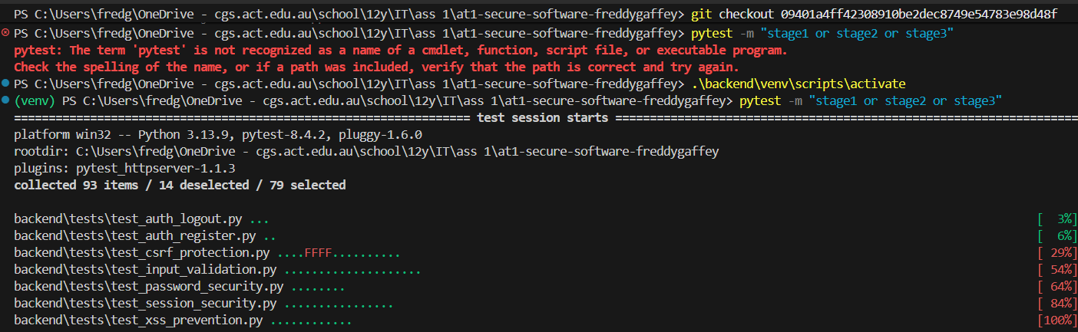
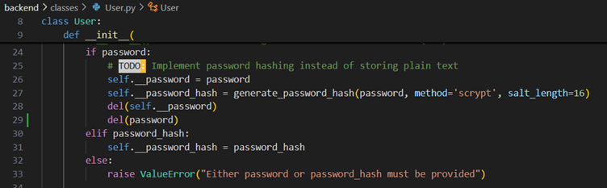

To fix this, imported the recommended function that hashes passwords and returns the password. Then I implemented the hashing as soon as the password was initiated, then I deleted the password to make sure that it would raise a value error if it was used again accidentally.

Input Validation:
Issue: User input not validated.
Solution: The solution is to use regex to do input validation with a combination of regex and if statements and raising a error
Before | The user input is not validated, allowing for invalid names, emails and passwords to be entered. This is a bad UI. Originally, the names were just stored in a variable and then written to the JSON database. There was no checking done.
After | git diff a8df384 45cc16a # to see the diff  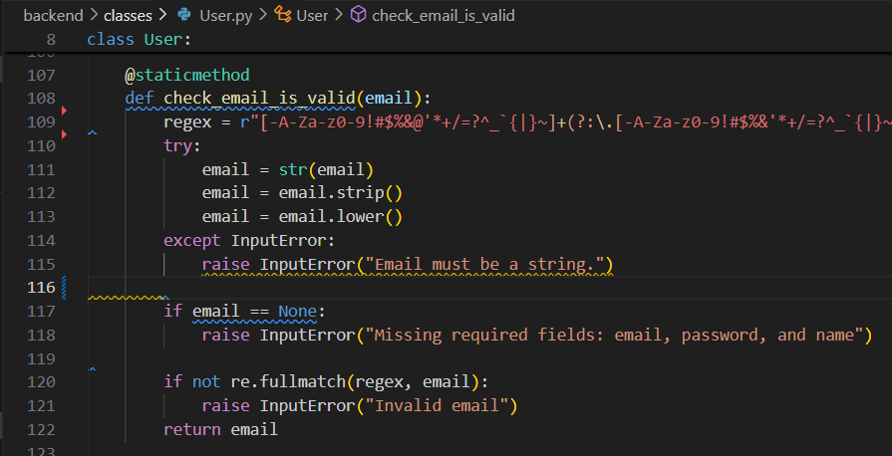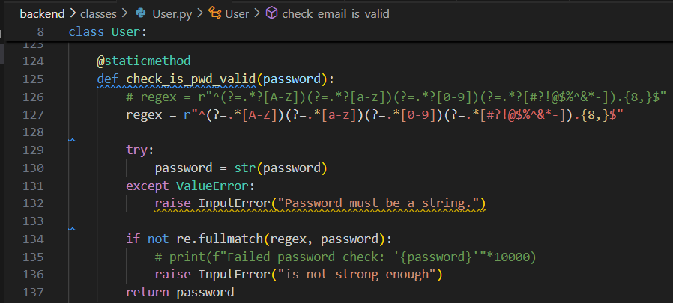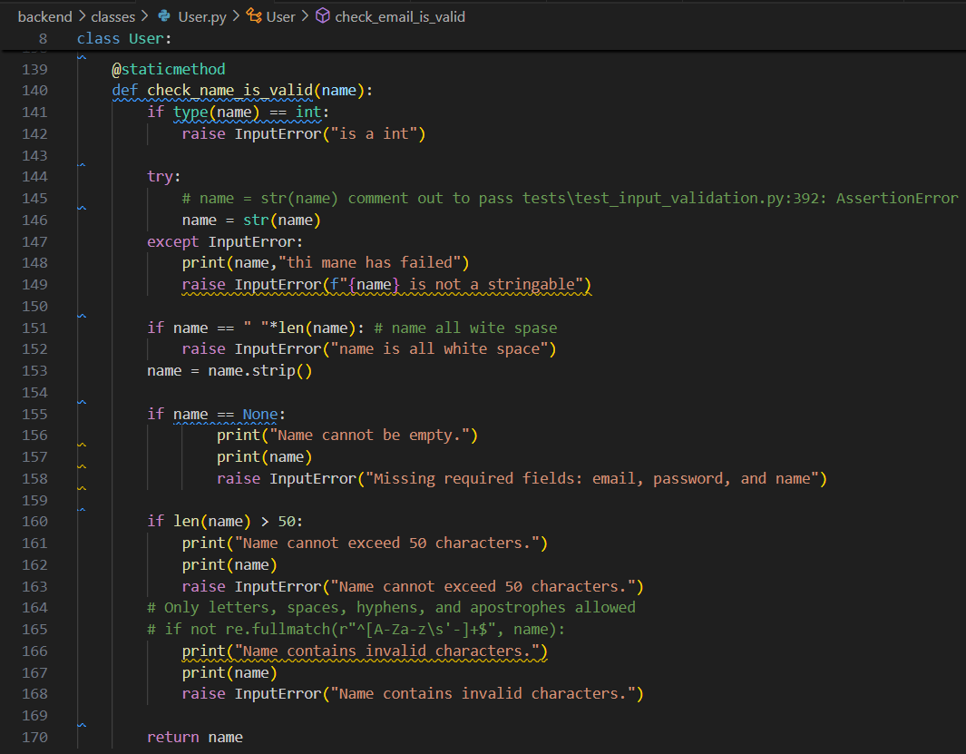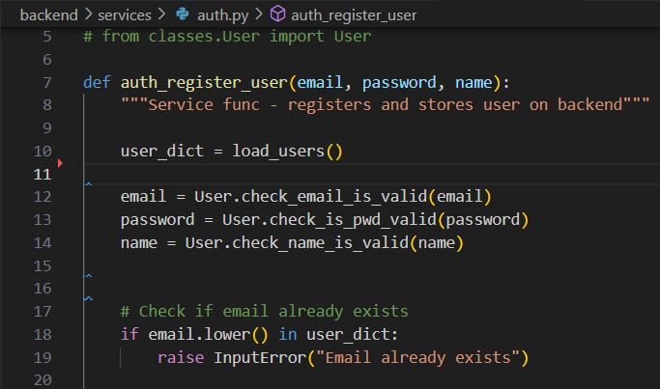  NOTE 26/11/25 I added in email length validation to be less then 300 characters I did  If len(email) > 300:  Raise InputError(“emal is to long”)
Steps | To do this stage I made a static method that uses a regex and some if statements to check if the inputted string is vaid. Then in the auth.py when the user is created and in User.py it will also check that the strings are vaid if they are not it will raise an InputError. This will protect the website from breaking from invalid input thus keeping the website up.  For email validation I started by checking if the emails could be turned into a valid string and then I applied a regex to it checked it wasn't none and a length check I did a very similar process for name but unlike email and name for passive validation I did a series of if statements as I wanted to make sure I knew exactly what was going on as this was a area which needed greater security.  I also made the function return the email name and password that had been validated this is a nice quality of life improvement
Proof of Stage | 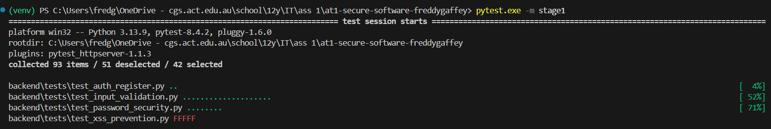

Input Sanitisation:
Issue: API is vulnerable to XSS attacks.
Solution: the
Before | There was no protection from inserting JavaScript and HTML tags in the input.
After | 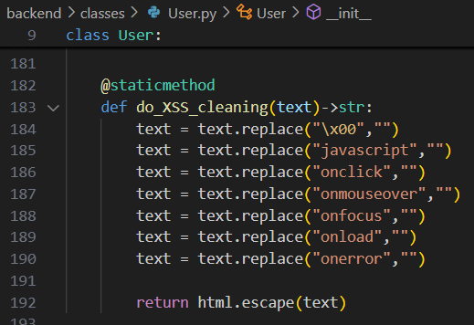  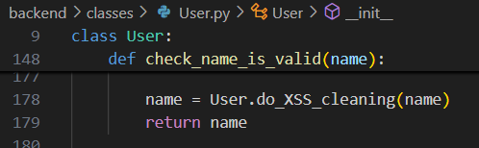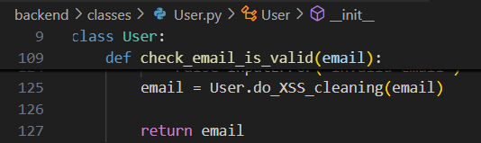
Steps | To do this annotation I made a sanitation function which applies find and replace and then finally does HTML escape meant then returns the escaped values  then I call this function in the last line of my user an name validation and it will return the sanitised version of the variable was imported into it and I can set that equal to the variable and then I can return the variable this means I don't have to modify or integrate the functions with complexity it is simple one liner that I can put before I return it
Proof of Stage

Stage 2 - Intermediate Security:
Session Management:
Issue: Currently, tokens are stored by email address. This is not secure as email addresses are very decryptable. A token must be added such that session tokens authenticate certain users.
Solution: The solution was to create a cryptographically secure session token instead of the insecure one. The original token was simply “unsecure-token” with the email address appended to it. I changed this to a cryptographically secure string generated by Python’s secrets module.
As well as this, I changed the location of the session storage token from cookies, which are readable by other website on the device, to be saved in session storage, which should be only readable to the original website. This protects the session tokens from being read, and therefore stolen, by other websites.

Before
Before and After | 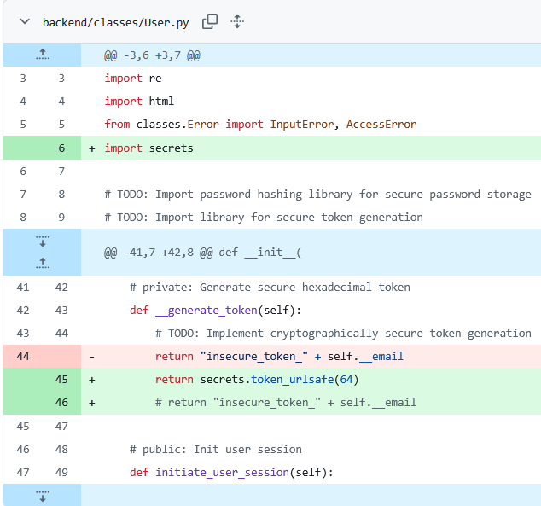  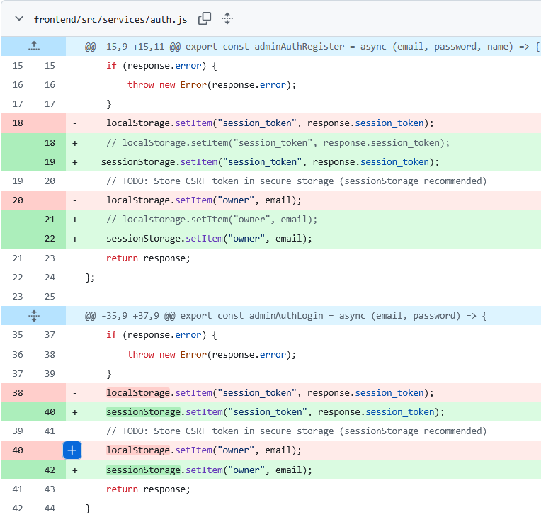  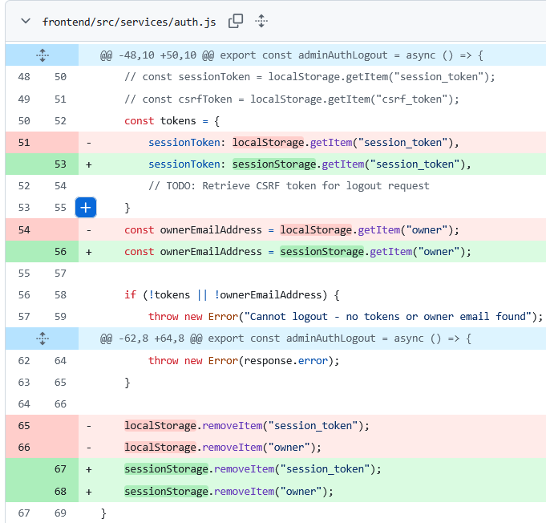  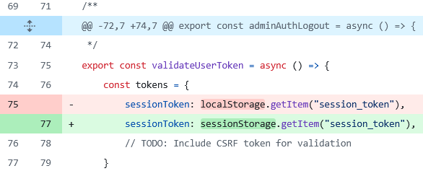
Steps | change the session token to be something secure instead of a generic string  Locate references to localStorage, and modify them to use the more secure sessionStorage.
Proof of Stage | I passed all the relevant tests

Invalid Forwarding:
Issue: Page redirection makes pages vulnerable to XSS attacks
Solution: check if the user has a valid session token before giving them a the page
Before | There was no validation when serving the user the webpage, instead, if they entered the correct URL they would be provided the page.
After | 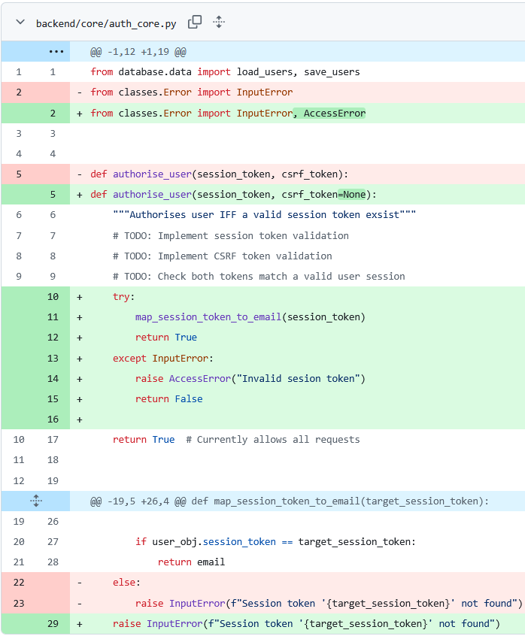  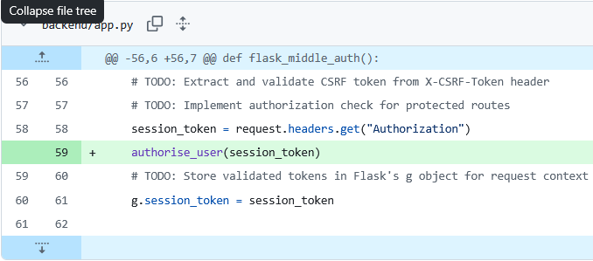
Steps | Make a function that searches the database to see if the token is valid this will raise an AccessError if it is not  Then call that function before you serve the webpage to the user
Proof of Stage

Stage 3 - Advanced Security:

CSRF Protection:
Issue: Currently, unauthorised users can access and obtain a session token. CSRF protection must be added so that only authorised users can access tokens, thus being able to use the pages.
Solution:

Before | The session tokens were simply stored in session storage so I had to update this so that it would not be stored there
After | Now session tokens are stored in the cookies this makes them only accessible on the particular domain therefore it protects it from cross site scripting
Steps | I really struggled to get the cookies to work so I got vs codes ai to make a MVP Flask website so I could see how to implement it simply  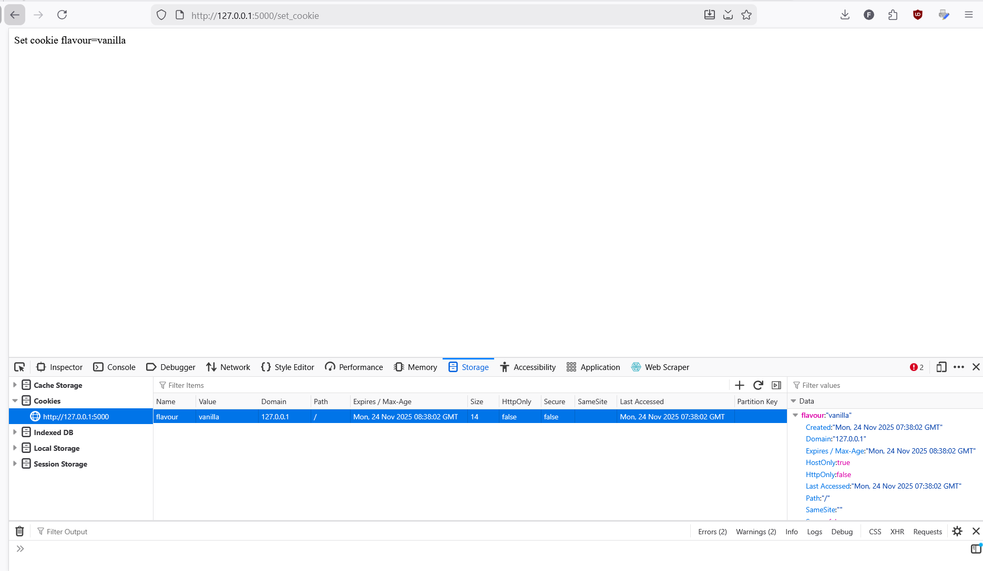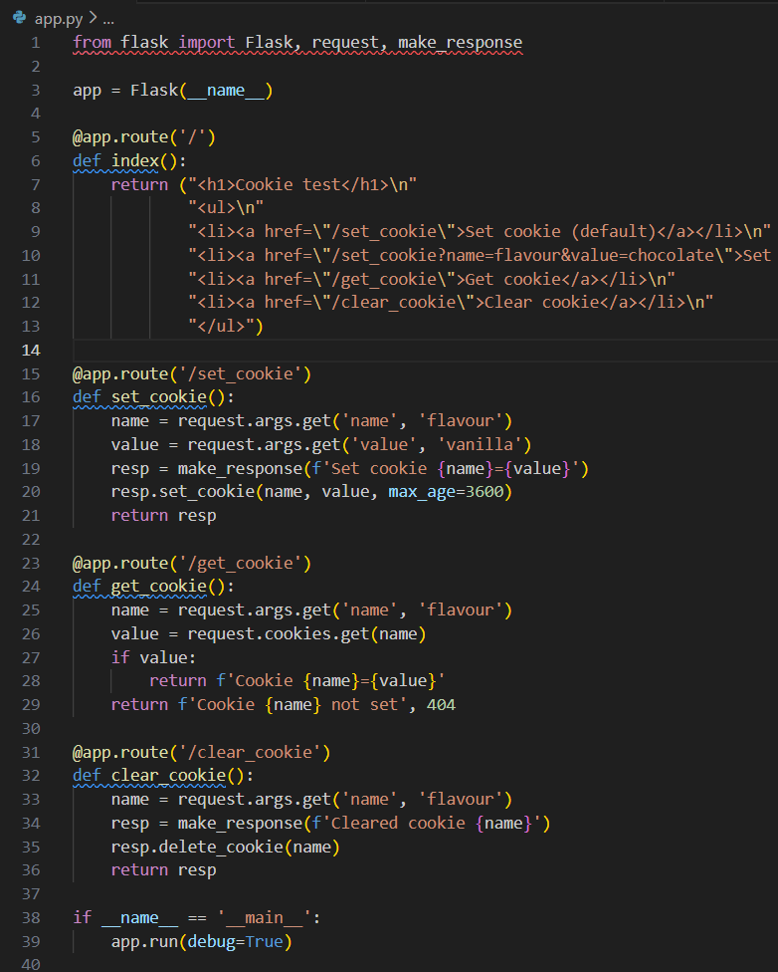  I used cursor to make this MVP. This is allowed as it is not part of the assignment  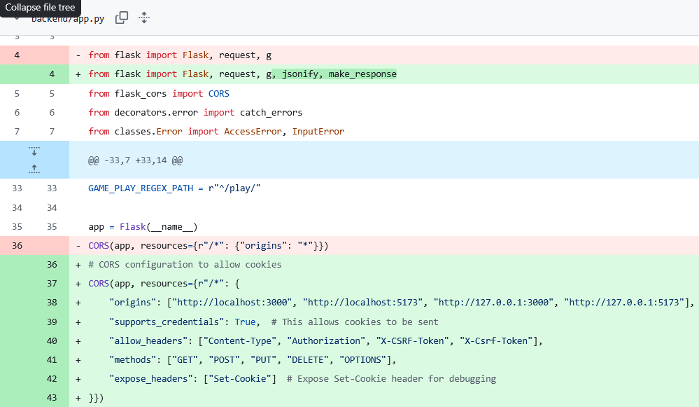  Here you can see that I am importing the library necessary libraries  Also I am allowing configuring the CORS (Cross-Origin Resource Sharing) to  allow it to share with the local front end  allow cookies  to allow the specific methods that I am using  to also expose the set cookie this is used for debugging  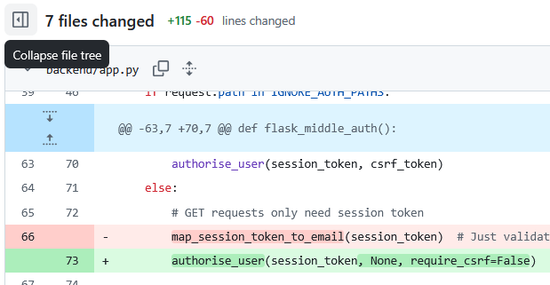  I updated the logging function to use the exiting auth function  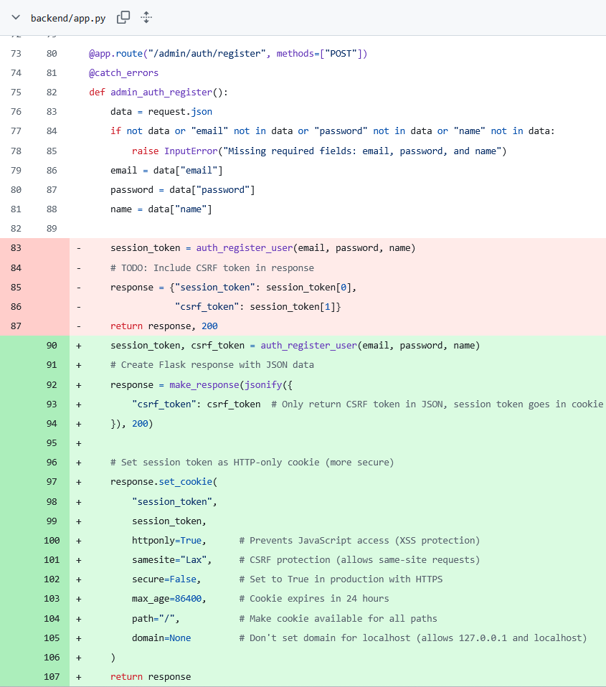  I redesigned the session token so that it would be not sent via a response but instead of this sent via a cookie attached to the response. To do this I made a flask object by using the make response and Jason of five functions and then I attached the cookie to the response with the set cookie method  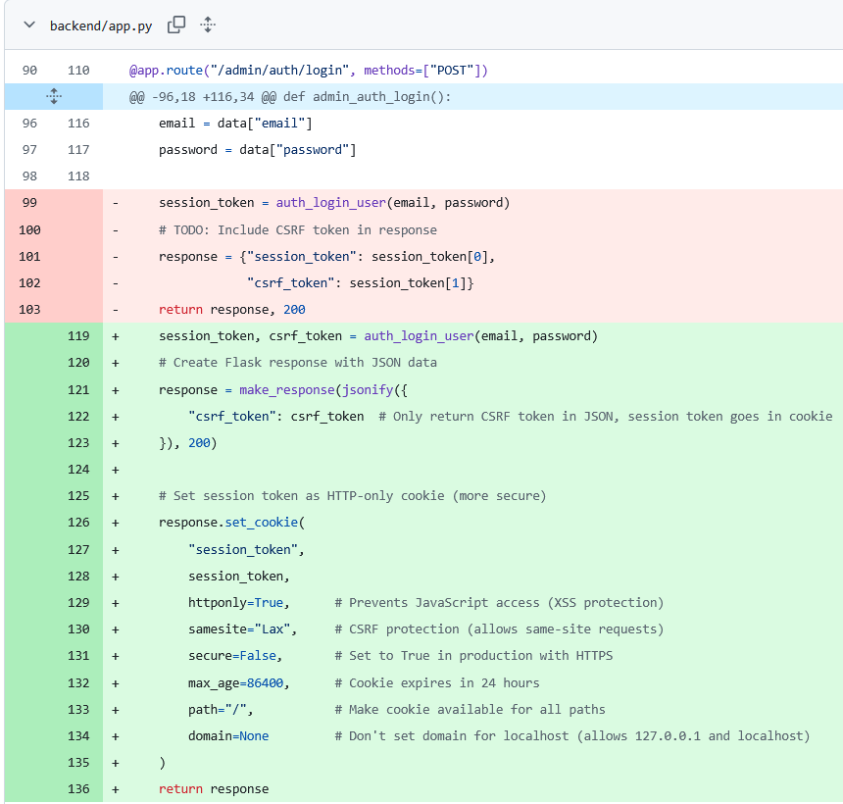  I did the same thing as above  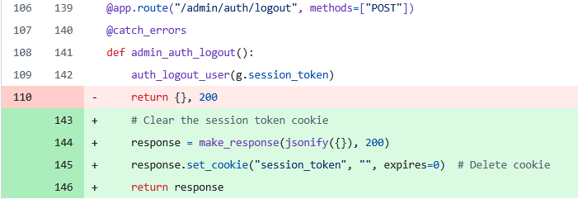  Instead of returning a dictionary that is empty I returned a dictionary that is empty as well as appending a cookie onto it that overwrote the session token with null end it expires after 0 seconds this is the effect of removing session target cookie from the browser  this makes it work will localhost  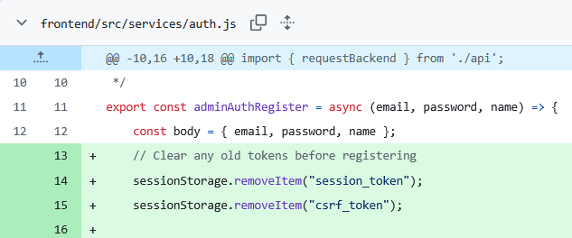  I was having a bug where I initially had all session and serif is tokens in the website from testing and to fix this I made sure I cleared the CRLS token and session token  I remove a lot of the times that the session token was called in the js it is not verry complex and it would be hard to read as it is a lot of images so I wont include it here.
Proof of Stage | 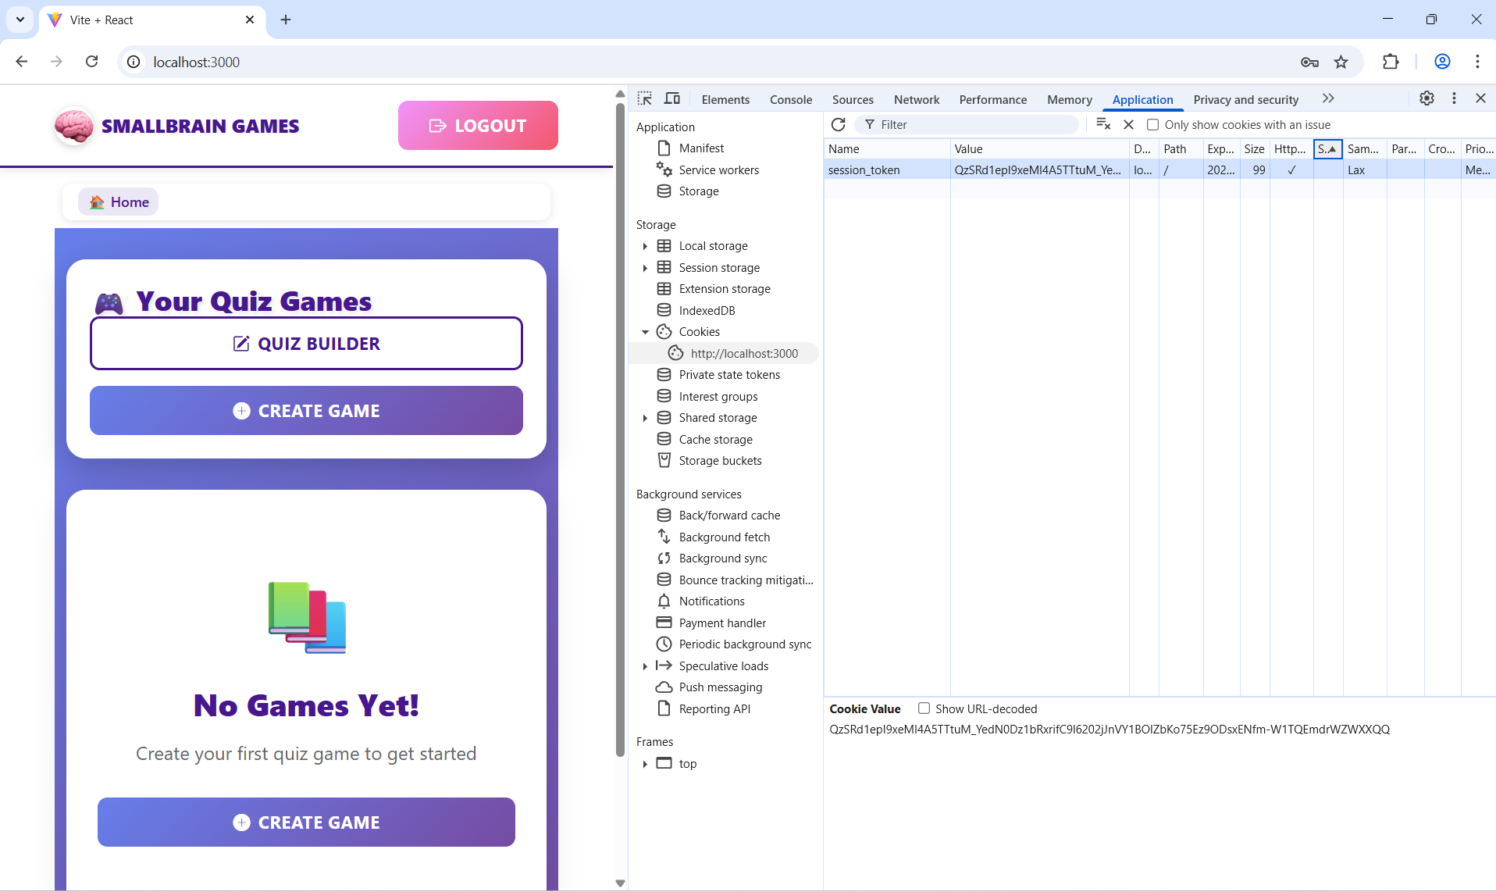

Token Validation:
Issue: Tokens are vulnerable to XSS attacks
Solution:
Before | There was no CRFS token implemented at all but a seer if it's token is quite similar to a session token So what I did was I simply duplicated the code more or less of a session token I made it work for a CRFS token
After
Steps | NOTE: I used this command frequently git reset --hard 09401a4ff42308910be2dec8749e54783e98d48f  I did my best to follow the TODO’s that were provided for this stage I basically had to implement an other session token so I could reuse that design pattern from the session token.  I first updated the User.py class to have the csrf_token in it. Next I made a new function in auth_core.py file this will validate the csrf_token. This function was based off the map_session_token_to_email but it instead did map_csrf_token_to_email this let me to handle the verification with minimal effort. Next I had to update where I called response “session_token” to also call the "csrf_token": session_token[1]. Now I passed all the tests but it was not done yet.  Now I still had to implement the front end with the sessionStorage this was the hardest step to over come not because out of technical competency but out of human error. I made frequent typos in the naming of “crfs” I called it almost all combinations of the letters “c” ”s” ”r” ”s” this and due to my dyslexia I struggled to spot the difference this made debugging CHALLANGING to say the least spent countless houre trying to use print debugging but I kept on getting a csrf token is “undefined”. At the suggestion of a friend I tried using cursor the ai ide to help me fix the typos. You can see some of my debugging process below. I also wrote the letters “CSRF” on my hand so I could check this each time.  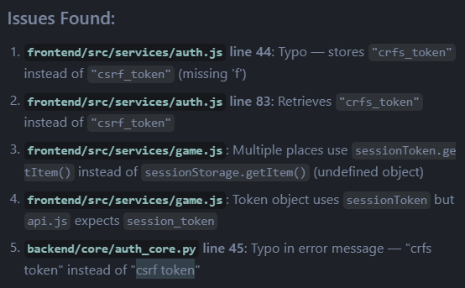  I also missed some details  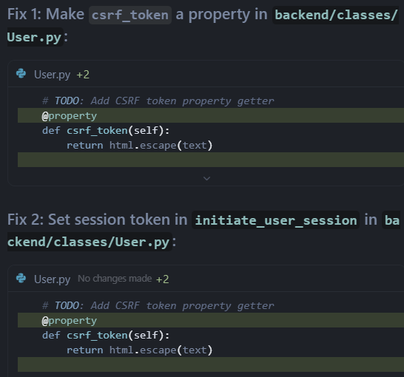  This shows some of my debugging  Once I got the website working I started failing tests from stage 2 so I needed to debug this  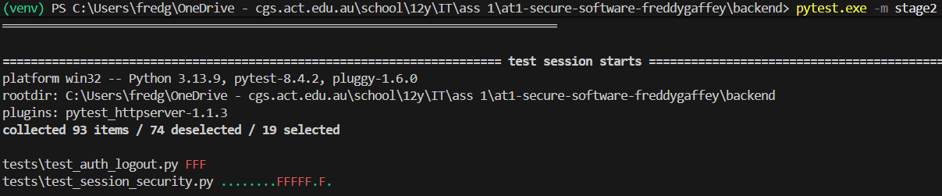  I tried to use git to revert back to the end of stage2_restart but I just broke it more do I decided to make a new branch off main. But I still got more errors that were not part of main I got verry confused and then I asked Sir for some help with git  I finally got it and git working so that the issue was I did not commit my .js files as I cd into the /backend dir and I did git add . and I didn’t relies that it would only stage the /backend files I was lucky enough that I could see my old progress from a older git stash
Proof of Stage

Stage 3.3 - Vulnerability assessment
This is the git diff I am using
https://github.com/SoftwareDesignDevKings/at1-secure-software-freddygaffey/compare/6216c56b9d62699050c837b0cfa6f2c023884364...main
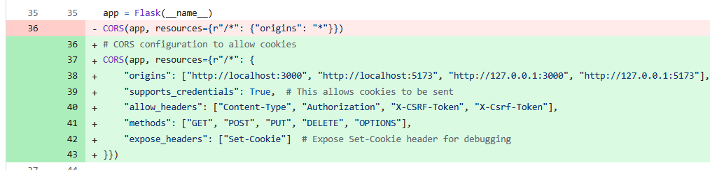
This is to implement cookies I need to give authorisation via CORS
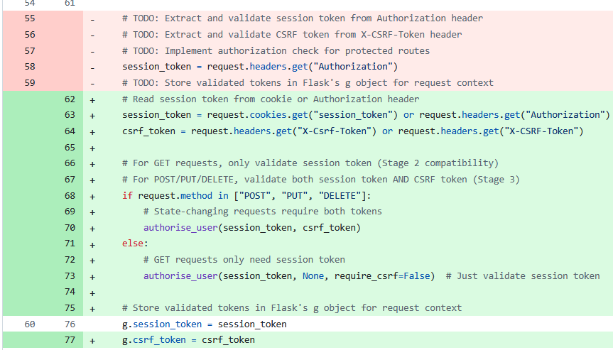
I have implemented session tokens and cookies here and I've also updated the Authorised user function not to always return true but to do actual authorization as seen below
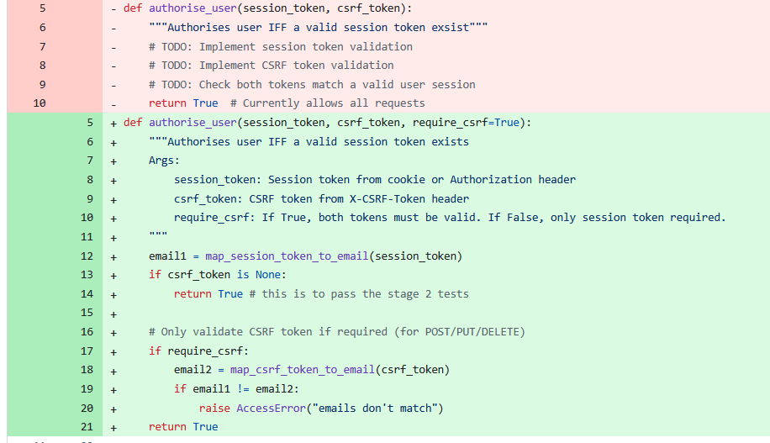
This is gone from always returning true to now calling the map token to email and map CRFS token to email functions and they will return a token if and only if it is in the database.’
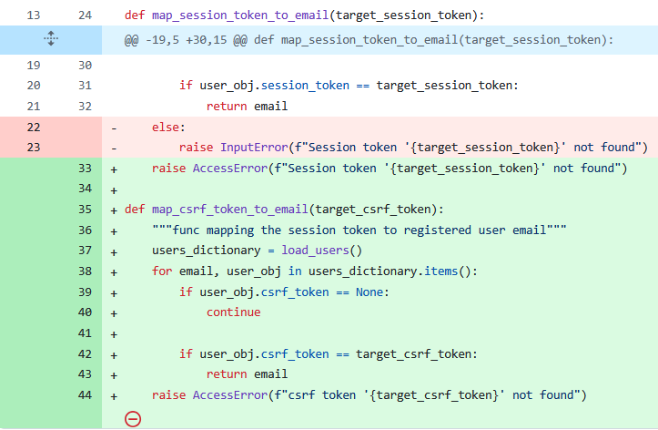
This is a map C refers token to email function I copied it from the above map session token to email but I change the variable names this enabled me to validate to the users csrf token.

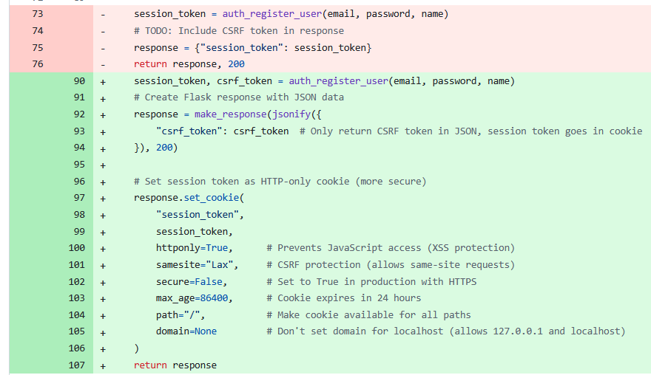
I've moved from only having a single insecure session token to now having a secure session token the distorted cookies and also a CRFS token stored in session storage I have done similar things in login and logout but in logout I set the session token to null
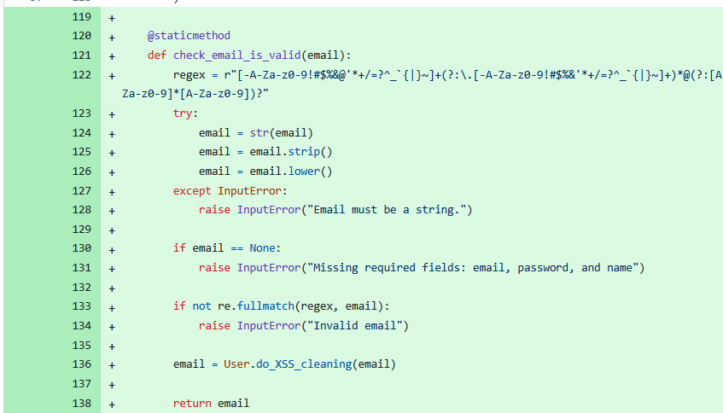
I've done email validation to check if an email is valid
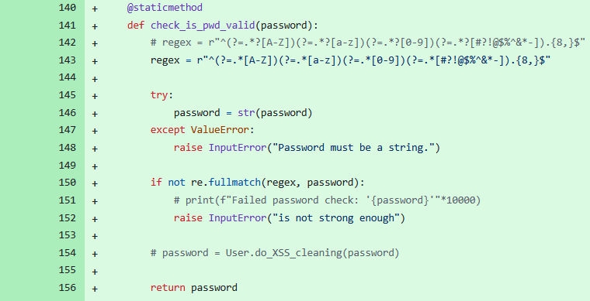I've done password validation
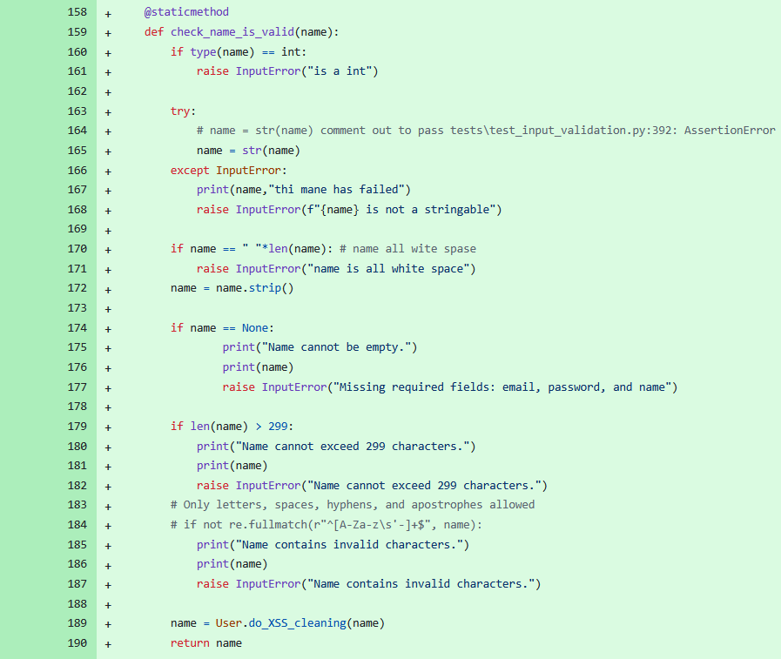name validation
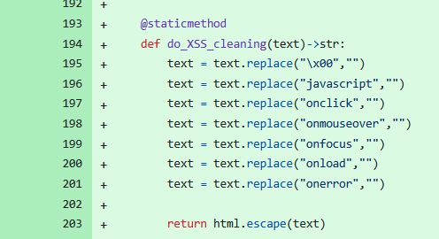
I have done XSS protection Then I have called this before I returned the name email or password in the above function
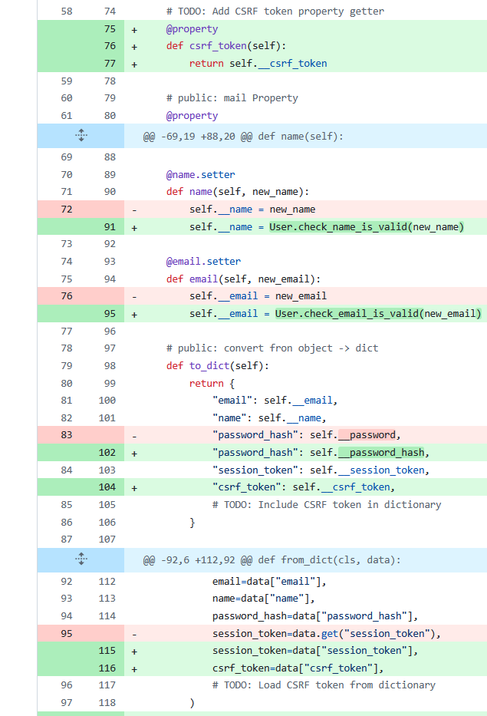The stuff that you see here is to enable the CRFS token
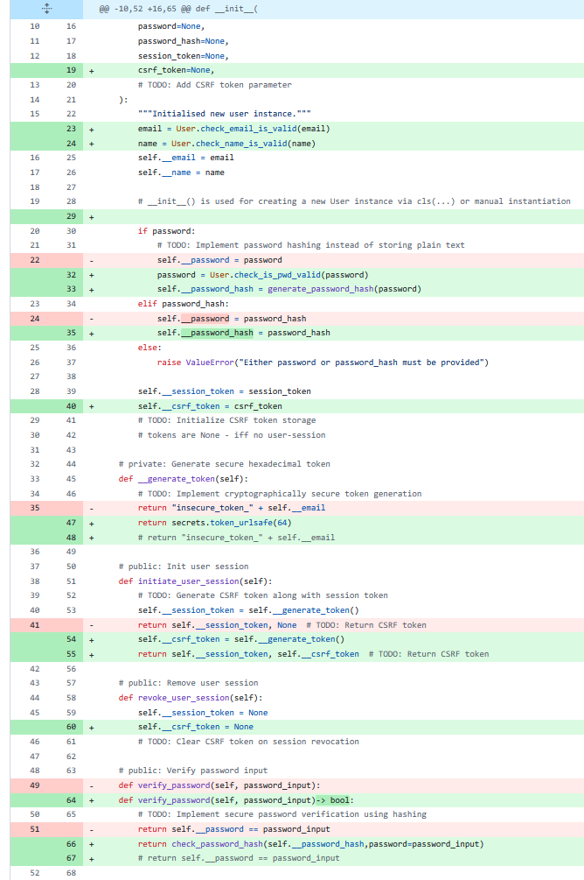Here I'm doing password hashing and also generating a session token and saving and revoking user session tokens
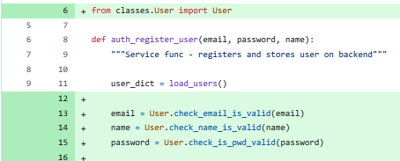
Email and password validation
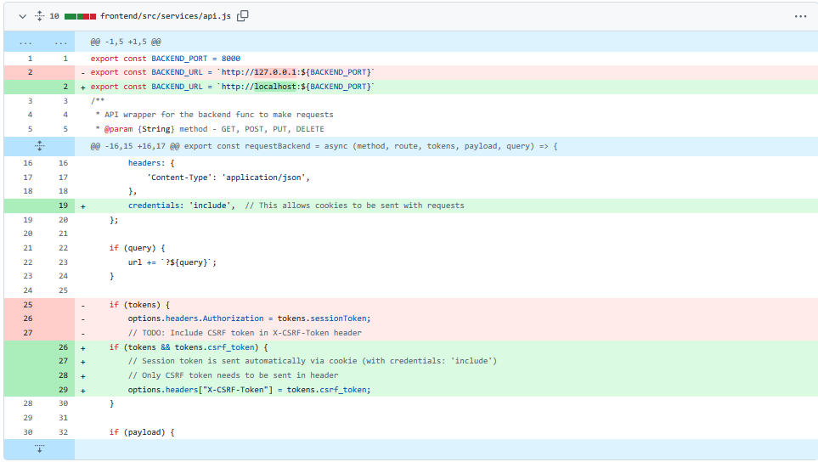

The credentials include bit in line 19 is very important it took me awhile to figure out to do that and that was very painful that enables cookies also I change it to localhost from the IP address that worked better and I also change it from using a session token to using a csrf token this is when I was increasing the security

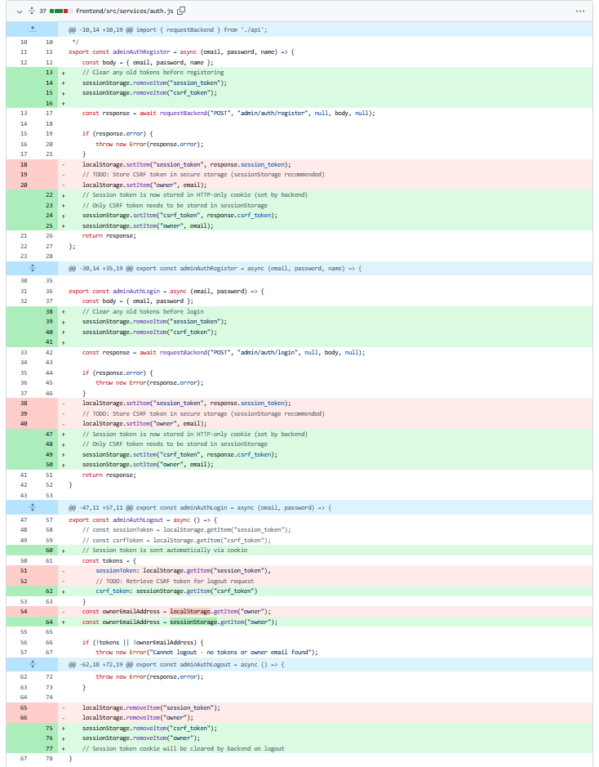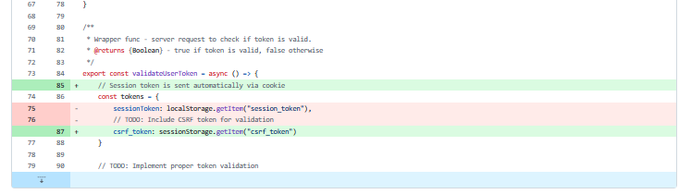
The above code handles the management to the js for authentication tokens

Code Review

SAST
bandit.exe -r backend -x backend/venv,backend/__pycache__,backend/**/__pycache__,backend/tests,tests -f html -o bandit-report.html
What this does
-r is the directory that it will run in
-x is the files it will ignore
-f is the format I chose to display the test results in
-o the output file name that the test are stored in

The results
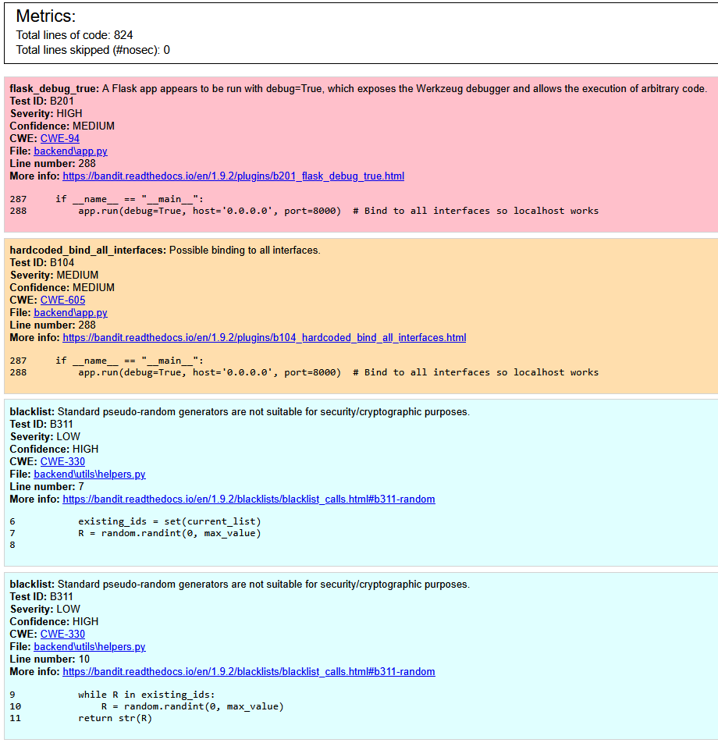
The first 2 errors are critical and I need to fix them. These are thing that I have created so upon fixing them this error is because I have left the code in a way that makes debugging easer

I changed the code to not use the debug options 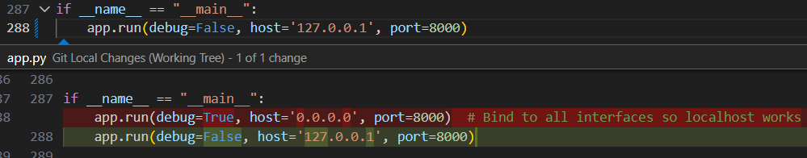

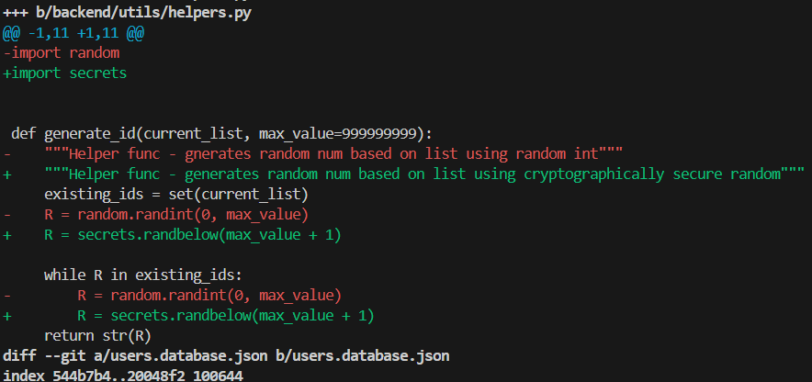
I made this function cryptographically secure I just don’t want bandit to complain I don’t think that is necessary though

Now, the bandit is finding no vulnerabilities
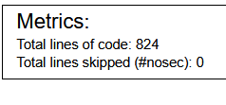

DAST
I have chosen to use ZAP for my DAST.
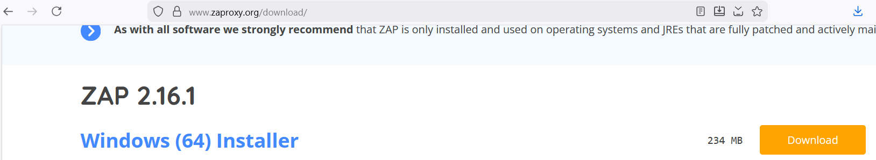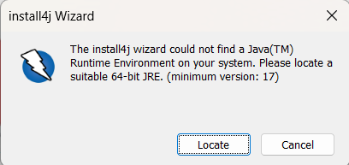
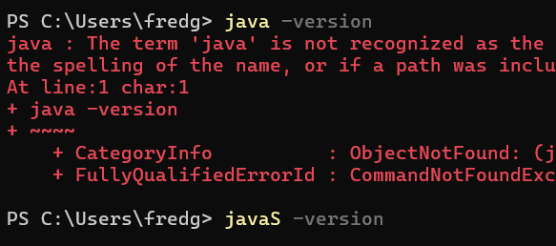
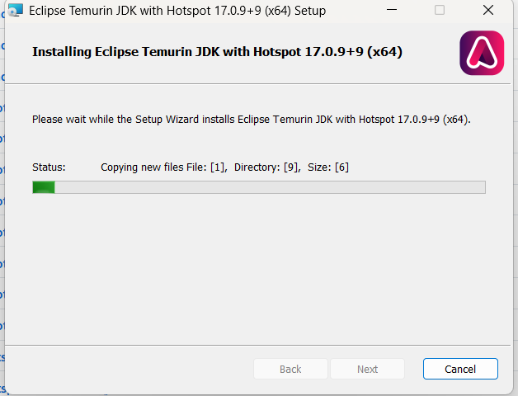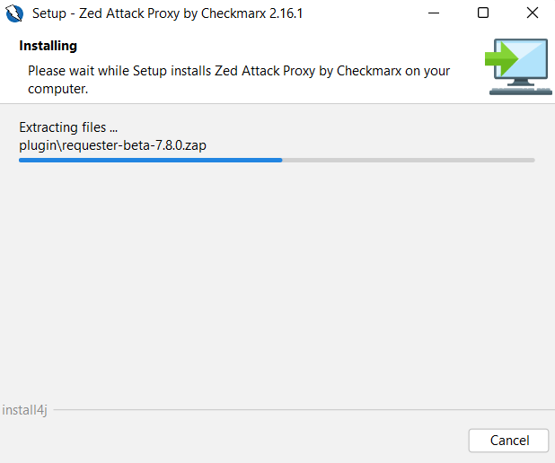

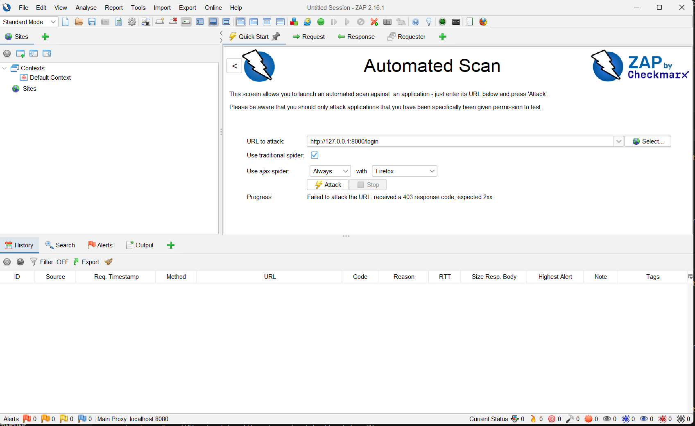I initially gave it the backend not the front end
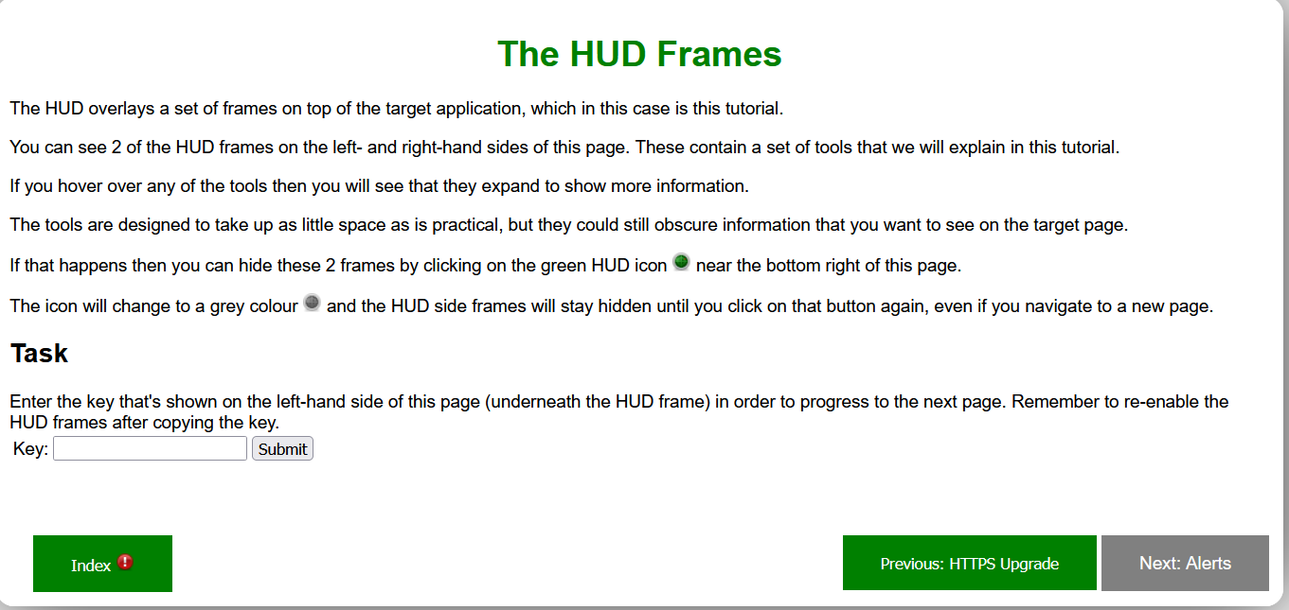
This is the result of exploring the zap application
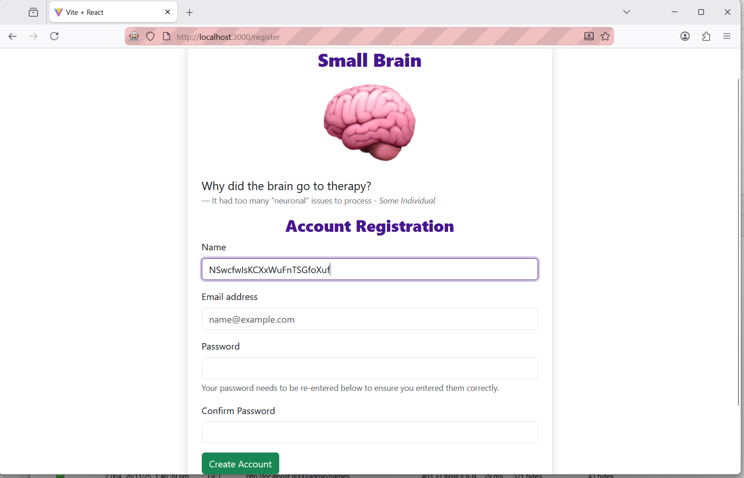here you can see that zap is attacking my website
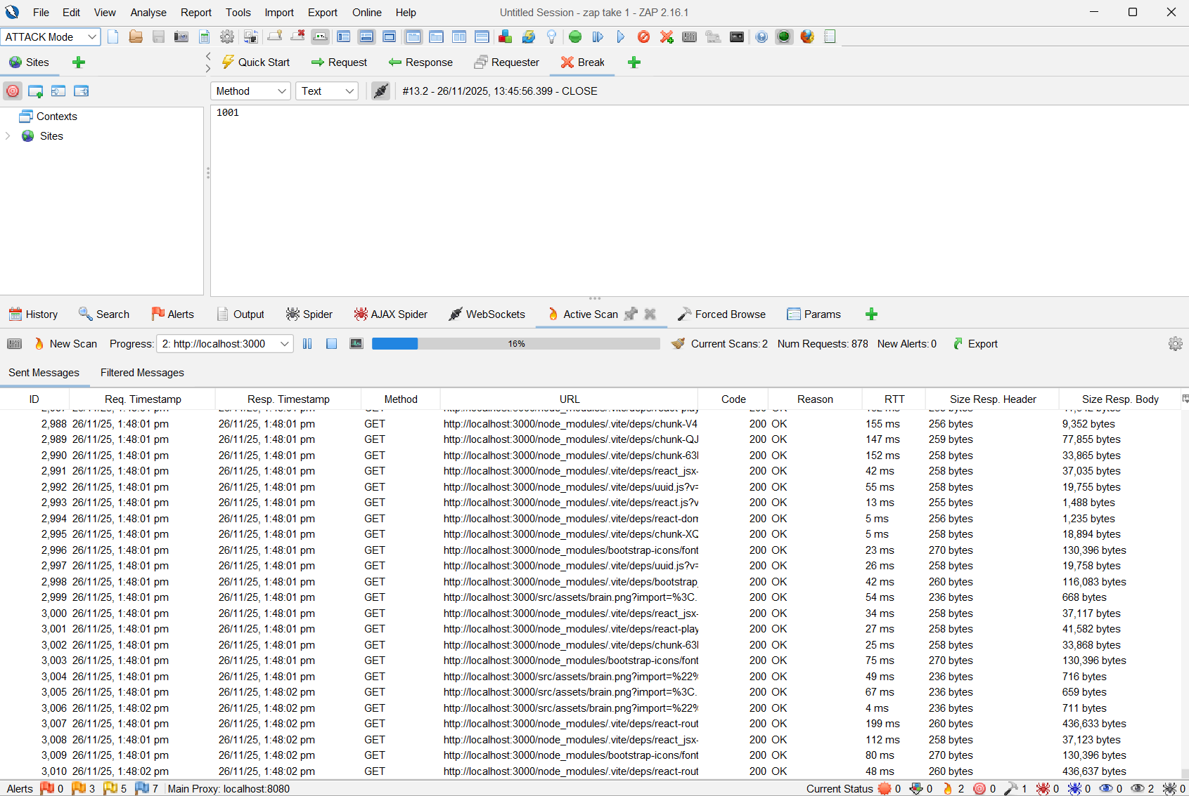
^^^ This is Zap sending the request to attack my website

The security vulnerabilities that were found through DAST
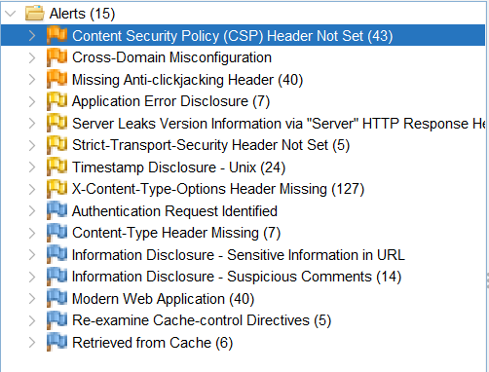

The errors found in my DAST were
Content Security Policy (CSP) Header Not Set - Content Security Policy (CSP) is an added layer of security that helps to detect and mitigate certain types of attacks, including Cross Site Scripting (XSS) and data injection attacks. These attacks are used for everything from data theft to site defacement or distribution of malware. CSP provides a set of standard HTTP headers that allow website owners to declare approved sources of content that browsers should be allowed to load on that page — covered types are JavaScript, CSS, HTML frames, fonts, images and embeddable objects such as Java applets, ActiveX, audio and video files. (zap)
Cross-Domain Misconfiguration - Web browser data loading may be possible, due to a Cross Origin Resource Sharing (CORS) misconfiguration on the web server. (zap)
The solution, according to zap is too “Ensure that sensitive data is not available in an unauthenticated manner (using IP address white-listing, for instance).
Configure the "Access-Control-Allow-Origin" HTTP header to a more restrictive set of domains, or remove all CORS headers entirely, to allow the web browser to enforce the Same Origin Policy (SOP) in a more restrictive manner.”
The error occurred because I set was using a wild card (*) in my CORS as the article on
“Using * as the value of the Access-Control-Allow-Origin header indicates that the application's data is accessible to JavaScript running on any domain.”
Fortify Software. “HTML5: Overly Permissive CORS Policy”. Vulnerability Catalog. Available at: https://vulncat.fortify.com/en/detail?category=HTML5&subcategory=Overly%20Permissive%20CORS%20Policy#Python (accessed 26 November 2025).

Click jacking attack – are a problem for banks and other institutions but are less relevant for the app as there is less critically scure data and the data is not that structured, making a click jacking hard but is is still achievable. This article from the OWASP group explains it better than I could “Clickjacking, also known as a “UI redress attack”, is when an attacker uses multiple transparent or opaque layers to trick a user into clicking on a button or link on another page when they were intending to click on the top level page. Thus, the attacker is “hijacking” clicks meant for their page and routing them to another page, most likely owned by another application, domain, or both.
Using a similar technique, keystrokes can also be hijacked. With a carefully crafted combination of stylesheets, iframes, and text boxes, a user can be led to believe they are typing in the password to their email or bank account, but are instead typing into an invisible frame controlled by the attacker.“ https://owasp.org/www-community/attacks/Clickjacking
Application Error Disclosure and simpler errors – This basically means I'm giving error message this is not a good thing as it helps provides information to the attacker on how your website works but it is not inherently vulnerable

An extensive and accurate evaluation of the effectiveness of your software engineering solution including security vulnerabilities and how they were fixed. Use the results of a SAST and DAST in your answer. Are there any other errors that could be fixed?

Evaluation:

